**BRAINSTORMING AND IDEA PRIORITIZATION**

|  |  |
| --- | --- |
| NAME | S.SATHISH |
| NM ID | D3AB4E60998F2BBA802428A0FF7D9B00 |
| ASSIGNMENT | BRAINSTORMING AND IDEA PRIORITIZATION |

**Page Link:**

<https://app.mural.co/t/landingpage4369/m/landingpage4369/1698486759674/452bf4aaf66c0b0336b0bd0d0342d1b6f5b81aa7?sender=u83846649c59736fc18bc0774>

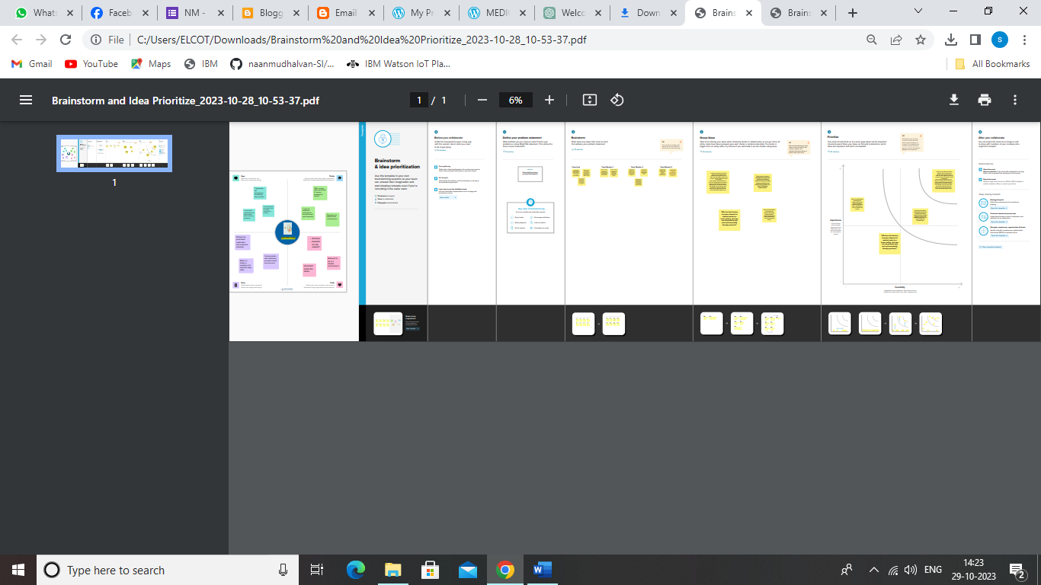

**PDF:**

